Image Captioning Using Transformer

# Introduction

This project uses a transformer [1] based model to generate a description for images. This task is known as the Image Captioning task. Researchers used many methodologies to approach this problem. One of these methodologies is the encoder-decoder neural network [2]. The encoder transforms the source image into a representation space; then, the decoder translates the information from the encoded space into a natural language. The goal of the encoder-decoder is to minimize the loss of generating a description from an image.

Figure 1: Encoder Decoder Architecture

As shown in the survey done by MD Zakir Hossain et al. [2], we can see that the models that use encoder-decoder architecture mainly consist of a language model based on LSTM [3], which decodes the encoded image received from a CNN, see *Figure 1*. The limitation of LSTM with long sequences and the success of transformers in machine translation and other NLP tasks attracts attention to utilizing it in machine vision. Alexey Dosovitskiy et al. introduce an image classification model (ViT) based on a classical transformer encoder showing a good performance [4]. Based on ViT, Wei Liu et al. present an image captioning model (CPTR) using an encoder-decoder transformer [5]. The source image is fed to the transformer encoder in sequence patches. Hence, one can treat the image captioning problem as a machine translation task.

This project is based on CPTR [5], as discussed below. The project uses PyTorch as a deep learning framework.

# Model

The CPTR [5] consists of an image patcher that converts images $x∈R^{H×W×C}$ to a sequence of patches $x_{p}∈R^{N(P^{2}×E)}$, where N is number of patches, $H$, $W$, $C$ are images height, width and number of chanel ($C=3$) respectively, $P$ is patch resolution, and $E$ is image embeddings size. Position embeddings are then added to the images patches, which form the input to twelve layers of identical transformer encoders. The output of the last encoder layer goes to four layers of identical transformer decoders. The decoder also takes words with sinusoid positional embedding.

The pre-trained ViT weights initialize the CPTR encoder [5]. I omitted the initialization and image positional embeddings, adding an image embedding module to the image patcher using the features map extracted from the Resnet101 network [6]. The number of encoder layers is reduced to two. For Resenet101 [6], I deleted the last two layers and the last softmax layer used for image classification.

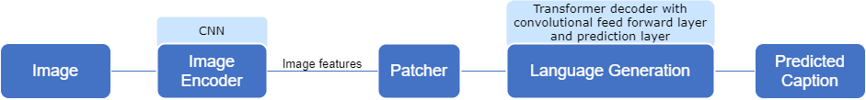Another modification takes place at the encoder side. The feedforward network consists of two convolution layers with a RELU activation function in between. The encoder side deals solely with the image part, where it is beneficial to exploit the relative position of the features we have. Refer to *Figure 2* for the model architecture.

Figure 2: Model Architecture

# Dataset

The dataset that I used is MS COCO [7] 2017, published by Microsoft. It is a large-scale object and keypoint detection, segmentation, and captioning dataset. COCO is often used to benchmark models/algorithms related to visual scenes understanding.

I redivided the train and validation splits into three, training, validation, and test splits; each contains 86300, 18494, and 18493 images. In the dataset, each image has five or more captions. Five random captions are selected during dataset preparation if more than five are available. Also, I neglect the words which occur less than three times and replace them with the "UNKOWN" special token. Other special tokens are used: the "start of the sentence", the "end of the sentence", and the "pad" tokens.

# Training

The transformer decoder output goes to one fully connected layer, which provides –given the previous token– a probability distribution ($∈R^{k}$, k is vocabulary size) for each token in the sequence.

I trained the model using cross-entropy loss given the target ground truth ($y_{1:T}$) where $T$ is the length of the sequence. Also, I add the doubly stochastic attention regularization [8] to the cross-entropy loss to penalize high weights in the encoder-decoder attention. This term encourages the summation of attention weights across the sequence to be approximatively equal to one. By doing so, the model will not concentrate on specific parts in the image when generating a caption. Instead, it will look all over the image, leading to a richer and more descriptive text [8].

The loss function is defined as:

$$L=-\sum_{c=1}^{T}{log\left(p\left(y_{c} | y_{c-1}\right)\right) + \sum_{l=1}^{L}{\frac{1}{L}\left(\sum_{d=1}^{D}{\sum_{i=1}^{P^{2}}{{\left(1-\sum_{c=1}^{T}{α_{cidl}}\right)}^{2}}}\right)}}$$

where $D$ is the number of heads and $L$ is the number of layers.

I used Adam optimizer, with a batch size of thirty-two. The reader can find the model sizes in the configuration file "code/config.json". Evaluation metrics used are Bleu [9], METEOR [10], and Gleu [11].

I trained the model for one hundred epochs, with stopping criteria if the tracked evaluation metric (bleu-4) does not improve for twenty successive epochs. Also, the learning rate is reduced by 0.25% if the tracked evaluation metric (bleu-4) does not improve for ten consecutive epochs. The evaluation of the model against the validation split takes place every two epochs.

The pre-trained Glove embeddings [12] initialize the word embedding weights. The words embeddings are frozen for ten epochs. The Resnet101 network [6] is tuned from the beginning.

# Inference

A beam search of size five is used to generate a caption for the images in the test split. The generation starts by feeding the image and the "start of sentence" special tokens. Then at each iteration, five tokens with the highest scores are chosen. The generation iteration stops when the "end of sentence" is generated or the max length limit is reached.

# Analysis

## Model Training

*Figure 3* and *Figure 4* show the loss and bleu-4 scores during the training and validation phases. These figures show that the model starts to overfit early around epoch eight. The bleu-4 score and loss value unimproved after epoch 20. The reason for overfitting may be due to the following reasons:

1. Not enough training data:
   1. The CPTR's encoder is initialized by the pre-trained ViT model [5]. In the ViT paper, the model performs relatively well when trained on a large dataset like

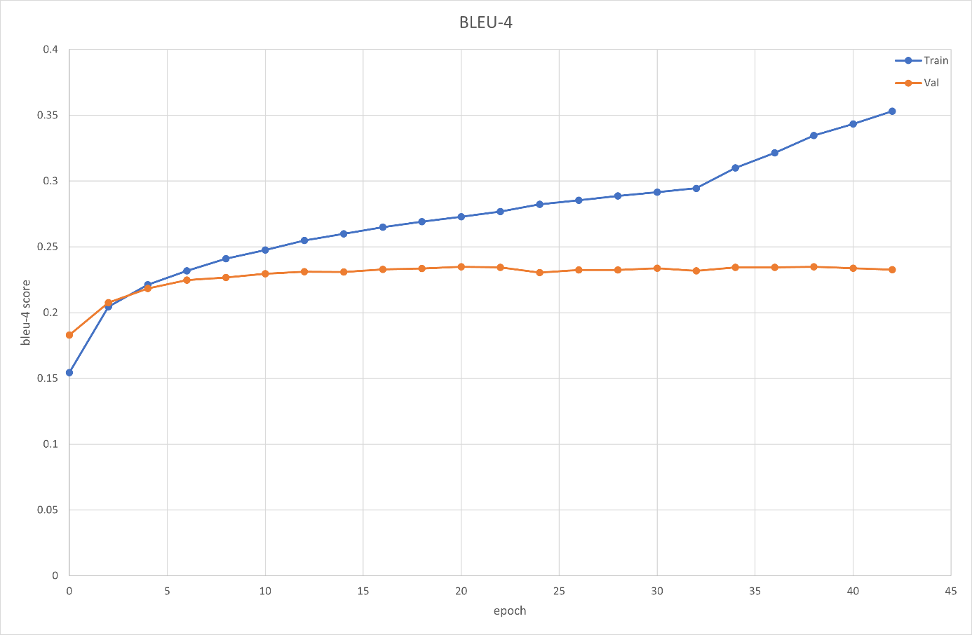

Figure 3: Bleu-4 Curve

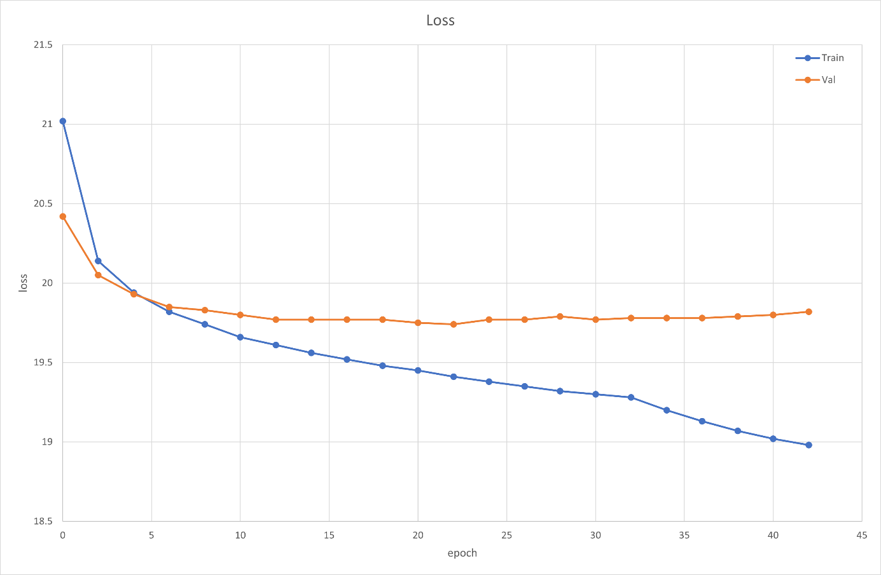

Figure 4: Loss Curve

ImageNet, which has 21 million Images [4]. In our case, the model weights are randomly initialized, and we have less than 18.5 K images.

* 1. Typically the dataset split configuration is 113,287, 5,000, and 5,000 images for training, validation, and test based on Karpathy et al.'s work [13]. My split has way fewer images in the training dataset and is based on the 80%, 20%, 20% configuration.

1. The image features learned from Resenet101 are patched to an $N$ patches of size $P×P$. Such configuration may not be the best design as these features do not have to represent an image that could be transformed into a sequence of subgrids. Flatten the Resnet101's features may be a better design.
2. The pre-trained Resent101 has been tuned from the beginning, unlike the word embedding layer. The gradient updates during early training stages where the model does not learn yet may distort the image features of the Resent101.
3. Unsuitable hyperparameters

## Inference Output

### Generated Text Length

*Figure 5* shows the generated caption's lengths distribution. The Figure indicates that the model tends to generate shorter captions. The distribution of the training caption's lengths (left) explains that behavior; the distribution of the lengths is positively skewed. More specifically, the maximum caption length generated by the model (21 tokens) accounts for 98.66% of the lengths in the training set. See “code/experiment.ipynb Section 1.3”.

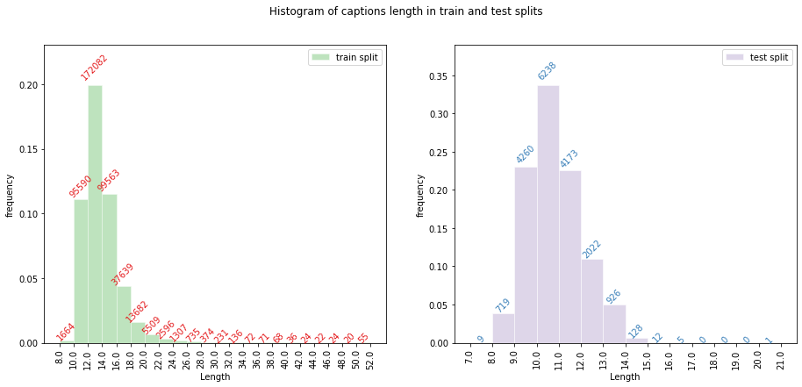

Figure 5: Generated caption's lengths distribution

### NLG Metrics

The table below shows the mean and standard deviation of the performance metrics across the test dataset. The bleu4 has the highest variation, suggesting that the performance varies across the dataset. This high variation is expected as the model training needs improvement, as discussed above. Also, the distribution of the bleu4 scores over the test set shows that 83.3% of the scores are less than 0.5. See “code/experiment.ipynb Section 1.4”.

|  |  |  |  |  |  |  |
| --- | --- | --- | --- | --- | --- | --- |
|  | bleu1 | bleu2 | bleu3 | bleu4 | gleu | meteor |
| mean ±  std | 0.7180 ± 0.17 | 0.5116 ± 0.226 | 0.3791 ± 0.227 | 0.2918 ± 0.215 | 0.2814 ± 0.174 | 0.4975 ± 0.193 |
|  |  |  |  |  |  |  |

### Attention Visualisation

I will examine the last layer of the transformer encoder-decoder attention. The weights are averaged across its heads. Section 1.5 in the notebook "code/experiment.ipynb" shows that the weights contain outliers. I considered weights that far from 99.95% percentile and higher as outliers. The outlier's values are capped to the 99.95% percentile.

Fourteen samples were randomly selected from the test split to be examined. The sample image is superimposed with the attention weights for each generated token. The output is saved in either GIF format (one image for all generated tokens) or png format (one image for each token). All superimposed images are saved under "images/tests". The reader can examine the selected fourteen superimposed images under section 2.0 from the experiments notebook, see Figure 6. You need to rerun all cells under Section 2.0. The samples are categorized as follows:

1. two samples that have the highest bleu4= 1.0
2. four samples that have the lowest bleu4 scores
3. two samples that have the low value of bleu4 [up to 0.5]
4. two samples that have bleu4 score= (0.5 - 0.7]
5. two samples that have bleu4 score=(0.7 - 0.8]
6. two samples that have bleu4 score= (0.8 - 1.0)

### Comments on Attention Visualizations

#### Determiner noun referencing:

It seems that the transformer can correlate the constituents of some linguistic expressions like determiner + noun and determiner + adjective + noun; as an example, Figure 7 and Figure 8 show the attention visualization for two noun phrases: "a man" [bleu4: 1.0], and "the dry grass" [bleu-4:.0373]. Some grammatical issues appear when the model fails to predict an object in the image, like "a laptop computer" [bleu-4: 0.03674]. The attention weight suggests that the model attends two computers, not one. Figure 10. Also, when the model is confusing about

an object, this uncertainty appears on the associated determiner attention weights. See Figure 9, which shows the attention weights for the phrase "a ball".

Figure 6

#### Spatial relations

The attention weights suggest that the model can describe spatial relations. For example, the model generates the following captions: "a clock mounts to it’s side" [bleu-4: 0.05915] (Figure 11), "a red stop sign sitting on the side of the road" [bleu-4: 0.19729] (Figure 12), "under the window" [bleu-4: 0.05522] (*Figure 14*), and "signs above" [bleu-4: 0.06034] (*Figure 13*). Although the bleu scores are too low and some of the detected objects are wrong, the model correctly described the spatial relations. For other similar examples, see "cat-a", "cat-n", "cat-s", and "cat-u" folders under "images/tests" directory.

#### Pronoun referencing

Interestingly, *Figure 11* and *Figure 15* give an example for the pronoun reference problem. While the attention weights suggest that the model correctly references the pronoun "it" to "building" in the first example, it seems that the model is confused about the pronoun "it" in the second example. The attention weight does not clearly indicate why the model wrongly referenced the pronoun.

#### Image semantics interpretation limitations

The description of a visual scene may vary depending on how the describer interprets the image semantics. In other words, the semantics could be described by the object(s) that the describer thinks are central to the scene and the viewpoint that the describer takes as a reference.

For example, in *Figure 15*, the model describes the image semantics in terms of the store, and it ignores the woman. As there is no sign that the model finds any difficulty detecting humans, one reason could be that the store is more prominent and in the center of the scene. In *Figure 15*, the model detects that the image is about a view of the city skyline, and this view is above the water. The resulting caption is awkward and grammatically poor.

By scanning captions generated by the mode, I notice that the linguistic capability of the model is limited. Most of the captions are noun phrases (75.84%) that consist of:

1. two noun phrases bound with a gerund verb $NP→NP VP$, $VP→VBG NP$; account for 56.05% of test split size. Note there is only one VGB in the caption,
2. two noun phrases bound with an adposition $NP→NP ADP NP$; account for 19.79% of test split size.

A simple linguistic expression like the ones above can be powerful because of the iterative nature of the language. Despite this feature, in my opinion, being able to express using only two linguistic expressions limits the ability of the model to generate rich text. More analysis is needed to see how deep the NP can go. Also, a look into the reference captions can help us understand whether such an NLP task needs a few simple expressions or more complex expressions are essential.

Another aspect that needs to be investigated is the meaning of verbs. Although some verbs appear to be used correctly, like standing (*Figure 8*), riding (*Figure 7*), and pitching (*Figure 9*), other verbs were used awkwardly. For example, in *Figure 10*, the model described the table being topped with a laptop computer. It appears it is the same use of pizza topped with vegetables. Another example is in *Figure 12*, where the model uses the verb "sitting" to describe a stop sign being at the side of the road.

These examples could indicate that the model detected sets of objects at the image encoder side and tried to bind them using verbs and adpositions using some statistically inferred rules like discussed above. More analysis is needed to investigate this hypothesis and to understand if the limitations in interpreting the image semantics are introduced from the visual or from the language generation side.

# References

[1] A. Vaswani *et al.*, 'Attention is all you need', *Advances in neural information processing systems*, vol. 30, 2017.

[2] M. Z. Hossain, F. Sohel, M. F. Shiratuddin, and H. Laga, 'A Comprehensive Survey of Deep Learning for Image Captioning', *arXiv:1810.04020 [cs, stat]*, Oct. 2018, Accessed: Mar. 03, 2022. [Online]. Available: http://arxiv.org/abs/1810.04020.

[3] S. Hochreiter and J. Schmidhuber, ‘Long short-term memory’, *Neural computation*, vol. 9, no. 8, pp. 1735–1780, 1997.

[4] A. Dosovitskiy *et al.*, 'An image is worth 16x16 words: Transformers for image recognition at scale', *arXiv preprint arXiv:2010.11929*, 2020.

[5] W. Liu, S. Chen, L. Guo, X. Zhu, and J. Liu, 'CPTR: Full Transformer Network for Image Captioning', *arXiv:2101.10804 [cs]*, Jan. 2021, Accessed: Sep. 20, 2021. [Online]. Available: http://arxiv.org/abs/2101.10804.

[6] K. He, X. Zhang, S. Ren, and J. Sun, 'Deep Residual Learning for Image Recognition', *arXiv:1512.03385 [cs]*, Oct. 2015, Accessed: Mar. 06, 2022. [Online]. Available: http://arxiv.org/abs/1512.03385.

[7] T.-Y. Lin *et al.*, ‘Microsoft COCO: Common Objects in Context’, *arXiv:1405.0312 [cs]*, Feb. 2015, Accessed: Mar. 07, 2022. [Online]. Available: http://arxiv.org/abs/1405.0312.

[8] K. Xu *et al.*, 'Show, Attend and Tell: Neural Image Caption Generation with Visual Attention', *arXiv:1502.03044 [cs]*, Apr. 2016, Accessed: Mar. 07, 2022. [Online]. Available: http://arxiv.org/abs/1502.03044.

[9] K. Papineni, S. Roukos, T. Ward, and W.-J. Zhu, 'Bleu: a method for automatic evaluation of machine translation', in *Proceedings of the 40th annual meeting of the Association for Computational Linguistics*, 2002, pp. 311–318.

[10] S. Banerjee and A. Lavie, 'METEOR: An automatic metric for MT evaluation with improved correlation with human judgments', in *Proceedings of the acl workshop on intrinsic and extrinsic evaluation measures for machine translation and/or summarization*, 2005, pp. 65–72.

[11] A. Mutton, M. Dras, S. Wan, and R. Dale, 'GLEU: Automatic evaluation of sentence-level fluency', in *Proceedings of the 45th Annual Meeting of the Association of Computational Linguistics*, 2007, pp. 344–351.

[12] J. Pennington, R. Socher, and C. D. Manning, 'Glove: Global vectors for word representation', in *Proceedings of the 2014 conference on empirical methods in natural language processing (EMNLP)*, 2014, pp. 1532–1543.

[13] A. Karpathy and L. Fei-Fei, 'Deep visual-semantic alignments for generating image descriptions', in *Proceedings of the IEEE conference on computer vision and pattern recognition*, 2015, pp. 3128–3137.